**How to View the Magma Math Assessment Results**

Log into Magma Math Through Clever- you will be directed to the assignments/assessments page.(You will need to log in under a teacher account)

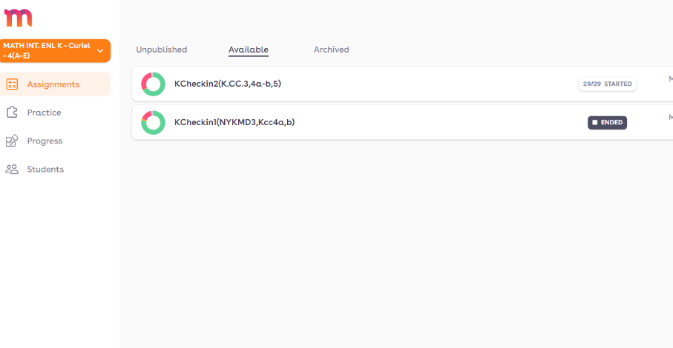

Click on the assessment

You will see the students names along with how they did according to colors.

**Green**= Correct on the first try  
​**Yellow**= Two attempts or more to get the answer right

**Red**= Wrong answer

**Eye**= The student has looked at the answer

**Grey** = solutions haven't been submitted (student did not complete assessment)

**Number =**How many times a student has turned in an answer

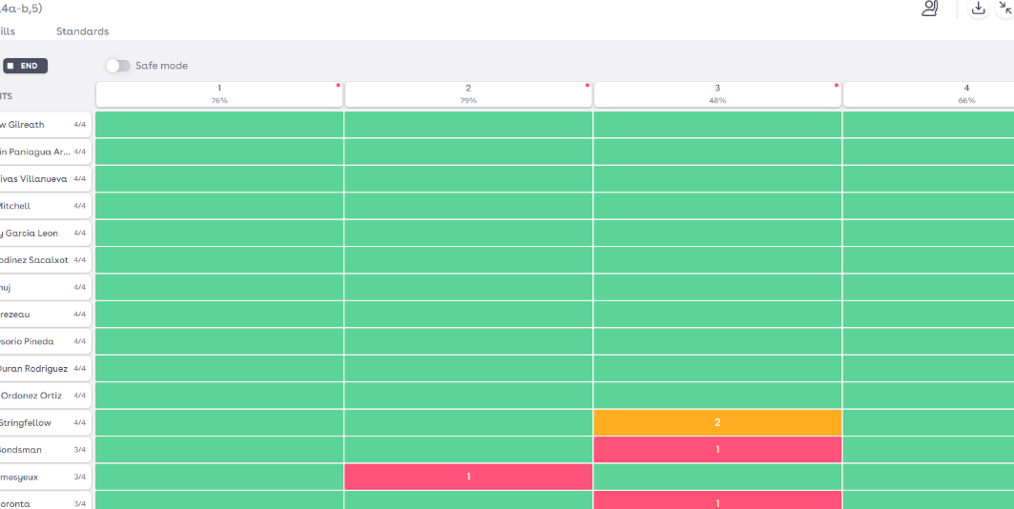

To see the students individual assessment click on their name.

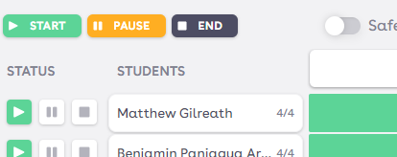

Their assessment and the work they showed will come up.

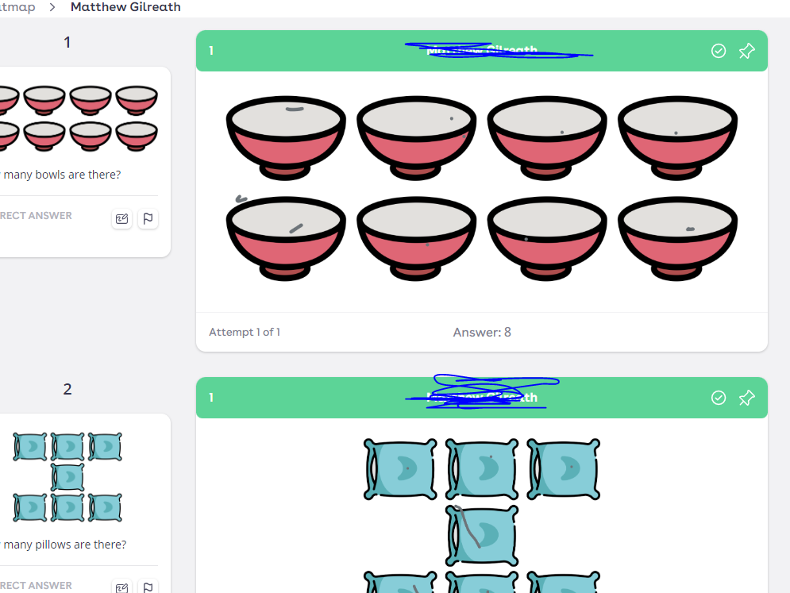

If you would like to see how the whole class did on a question click on the arrows to go through the othe students.

